Answers - HOMEWORK - Basic III lesson 1
- 1) To memorize the vocabulary colors, adjectives .
- 2) To learn the family tree.
- 3) To make 05 phrases with the verb to be in the present
- 4) To write the dialogues – three times
- 5) To try to understand the meaning of the song and the article – Sustainability.

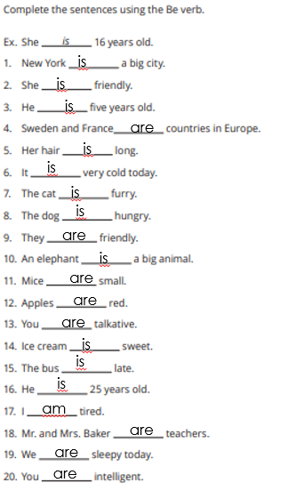

Complete de sentences using the adjectives
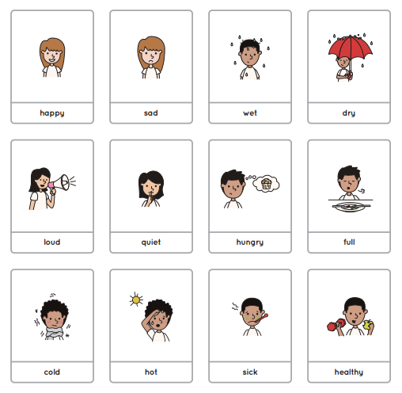

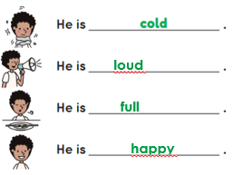

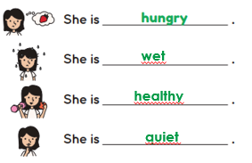

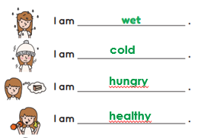
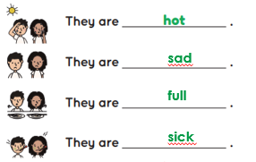

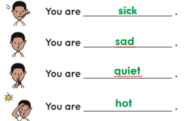

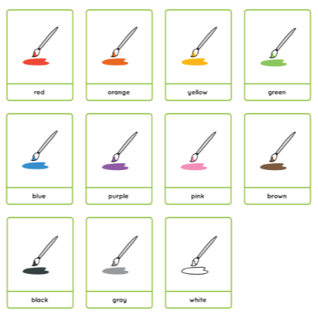

Answer the questions below
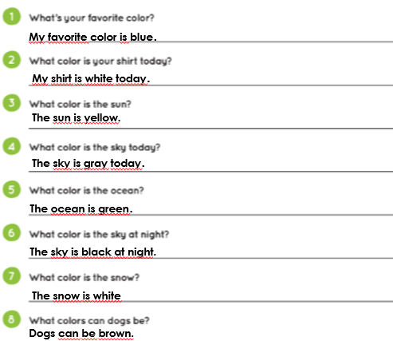

-Write the dialogues three times each sentence (3x)
- Introducing yourself (slides 2)
- Phrases and idioms (slides 3,4)
- Greetings (slide 5)
- Trying to understand (slide 6)
- Family tree (slide 16)
- Questions (slide 17)

-Listen and complete the song
-Listen to the report

