HOMEWORK - Basic III lesson 1
- 1) To memorize the vocabulary colors, adjectives .
- 2) To learn the family tree.
- 3) To make 05 phrases with the verb to be in the present
- 4) To write the dialogues – three times
0
-Write the dialogues three times each sentence (3x)
- Introducing yourself (slides 2)
- Phrases and idioms (slides 3 ,4)
- Greetings (slide 5)
- Trying to understand (slide 6)

-Listen to and complete the song
-Listen to the report

- 5) To try to understand the meaning of the song and the article – Sustainability.

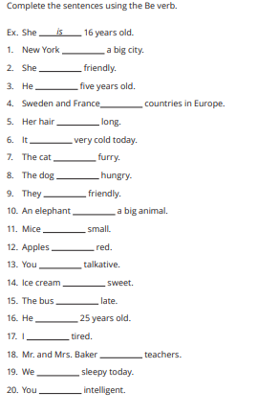

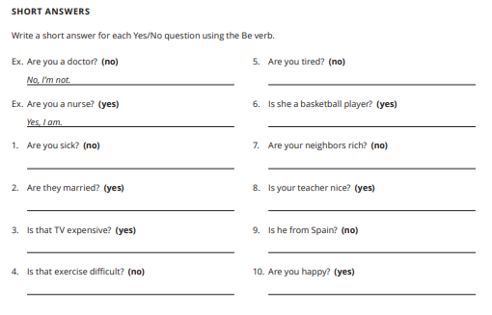
0
-Write the dialogues three times each sentence (3x)
- Introducing yourself (slides 2)
- Phrases and idioms (slides 3 ,4)
- Greetings (slide 5)
- Trying to understand (slide 6)

-Listen to and complete the song
-Listen to the report

Complete de sentences using the adjectives

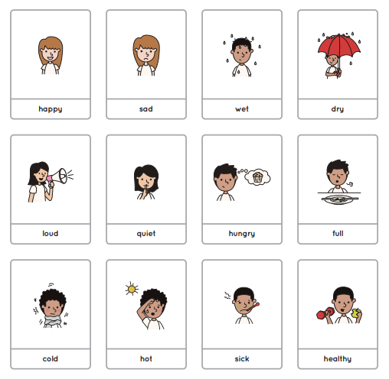
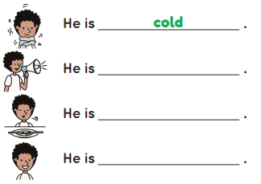
0
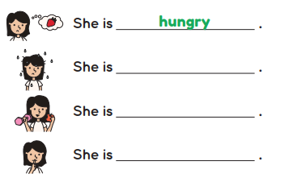
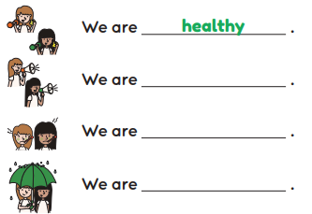
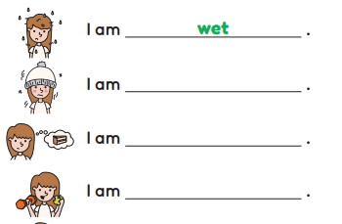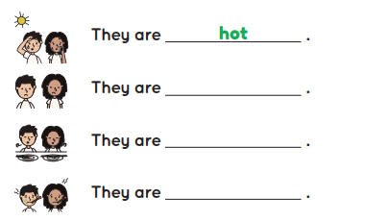

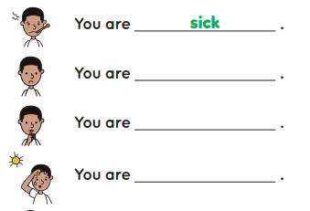

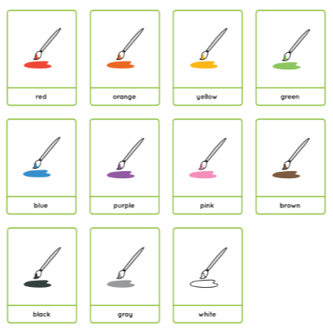
0
-Write the dialogues three times each sentence (3x)
- Introducing yourself (slides 2)
- Phrases and idioms (slides 3 ,4)
- Greetings (slide 5)
- Trying to understand (slide 6)

-Listen to and complete the song
-Listen to the report

Answer the questions below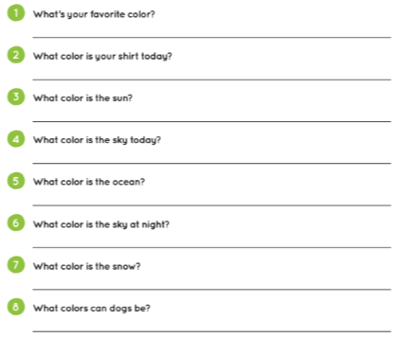
0

-Write the dialogues three times each sentence (3x)
- Introducing yourself (slides 2)
- Phrases and idioms (slides 3,4)
- Greetings (slide 5)
- Trying to understand (slide 6)
0
-Write the dialogues three times each (3x)
- Introducing yourself (slides 2)
- Phrases and idioms (slides 3 ,4)
- Greetings (slide 5)
- Trying to understand (slide 6)

-Listen to and complete the song
-Listen to the report

- Family tree (slide 16)
- Questions (slide 17)

-Listen and complete the song
-Listen to the report

Enjoy your weekend! _

